Press Release

Date: | 2020
email: | PressTeam@durham.gov.uk
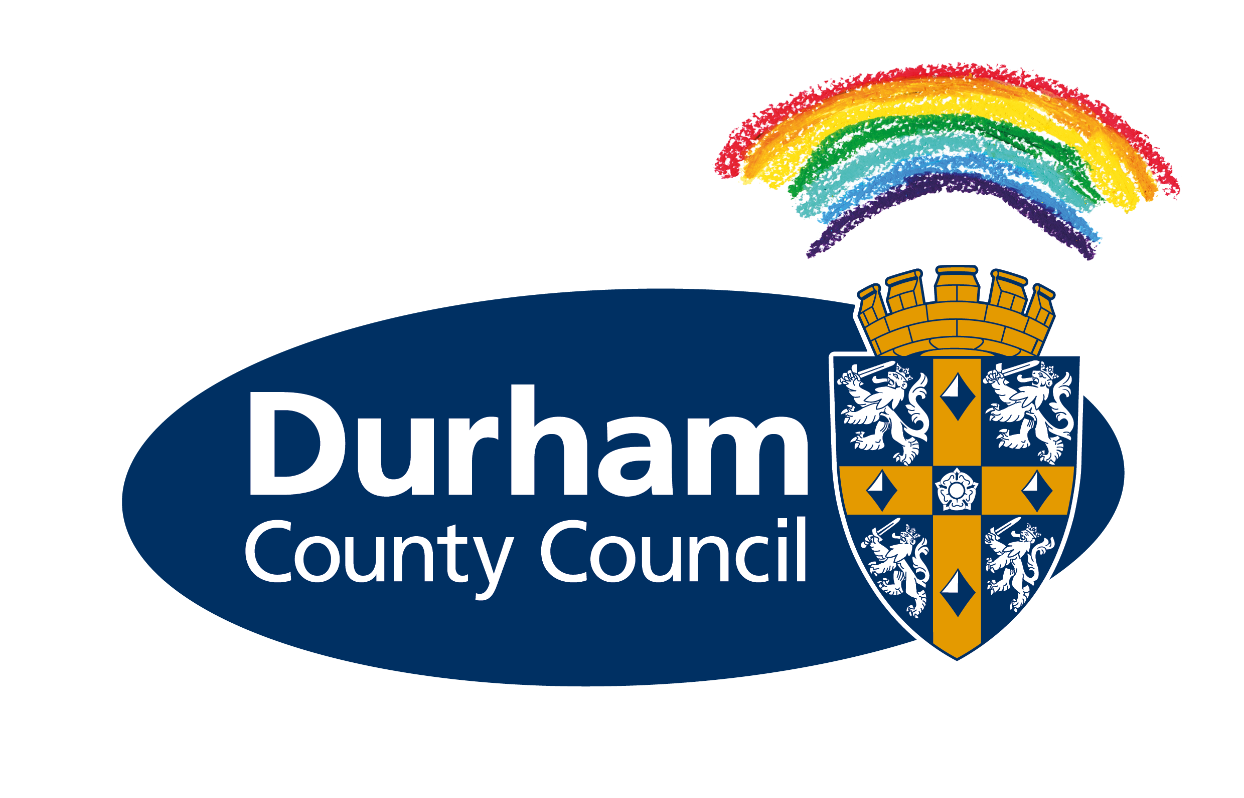
Council launches free school meals scheme for half-term

As children across County Durham begin their half-term holiday, a new voucher scheme has been launched to support families who rely on free school meals.

Durham County Council announced it would step in to provide this vital support last week following the House of Commons vote against extending the national school meals scheme to cover school holiday periods.

From today (Monday), parents and carers whose children are eligible for means-tested free school meals will be able to apply for one £15 voucher per child on council’s website at www.durham.gov.uk/freeschoolmeals. After filling in a form, they will then be sent a QR code, which can be redeemed at any PayPoint or Post Office and used to buy food and drink supplies. Residents can find their nearest PayPoint at www.paypoint.com/en-gb/consumers/store-locator or Post Office branch at www.postoffice.co.uk/branch-finder.

Anyone who struggles to access the internet or does not have a device that would support the digital code can call the local authority’s County Durham Together community hub on 03000 260 260. Staff will be on hand from 9am to 5pm, Monday to Friday, to help people with the forms or talk through other options.

The scheme will run throughout this week, but the council will ensure it is extended to cover the Christmas holidays if the Government’s position does not change.

Cllr Angela Surtees, the council’s Cabinet member for social inclusion, said: “We know how vital free school meals are and, following the Government’s decision not to provide support during holiday periods, we have acted quickly to set up a scheme to help families in need.

“Figures from the End Child Poverty commission have shown that 35 per cent of children in the North East are living in poverty and the coronavirus pandemic has created additional pressures on our communities. Our voucher scheme aims to ensure no child goes hungry during this holiday week and will complement the excellent support already being provided by dedicated community groups and venues across the county.”

Continues…

Cllr Olwyn Gunn, Cabinet member for children and young people’s services at the council, said: “County Durham people have a proud and enviable record of looking after each other in troubled times. I’m pleased our council has taken the lead in keeping with this tradition.’

Durham County Council supports a number of schemes across the county providing activities and food for children and young people during the holidays. To find out about activities taking place, visit www.countydurhamgamilies.info and search for VCS Alliance in the keywords box.

Ends

