A Big Maths Day Out!
Congratulations KS2!
You have all worked so hard this year so we have decided to treat you to a day out at a new Theme Park in Barnard Castle!

But first, you must plan your day!

You need to plan how long you will spend at the park and make sure you have transport to the park and back home.
You must also think about in which order you will go on the rides and whether or not you have time to visit the gift shop.
As well as planning your timings, you also need to plan your money. From entry costs to ride costs, food prices to gift shop treats, you must make sure you don’t go over your £30 budget per person!
Work in teams to plan a fun day out for you and your friends! How many activities can you do (and what yummy food can you buy)?
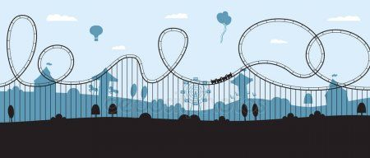
Good luck and have fun!
Miss Gillard

