Class Flags
Hi everyone!
I hope that you and your families are all well and are staying safe.
Here is an activity I thought might be nice for helping us all reconnect with one another, even though we are still apart.
- Talk to a friend or someone in your family to help you think of a value that is important to you. A value is a behaviour that is important to share and show to others, such as love, respect, courage or empathy.
- Use your chosen value to create your own mini flag (A5 sized – half a sheet of A4 paper).
Write your word in the middle of your sheet and then design your flag using colours and pictures. There are some examples below for you to have a look at.
- When we are all back in school together, we will put all our smaller flags together to make our team flag, which will be displayed in our classroom so please keep your flag safe!
By creating a whole class flag made up of smaller flags, we remember that we are all part of the same team, of something bigger than ourselves and that we all belong.
I hope you enjoy this activity and I can’t wait to see you all as soon as possible!
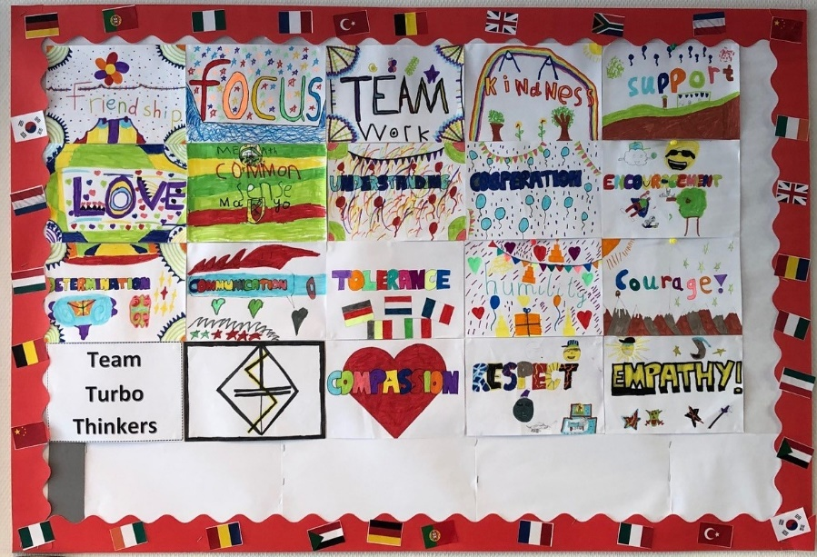
Take care and keep smiling!
Miss Gillard

(Example from TES website)

