22/06/20
Hello All Children, Parents & Carers,
We hope you’re all still keeping safe, well and happy!
GARDEN-ing!
Flower Petal Suncatcher
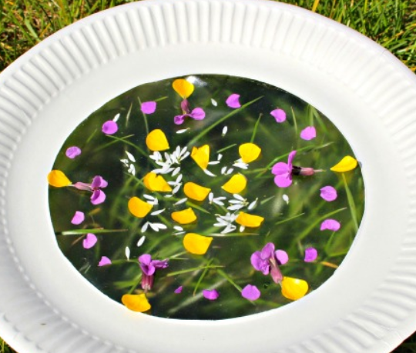
- Cut the centre of a paper plate.
- Cut out a circle of sticky back plastic that is slightly bigger than the hole in the paper plate.
- Stick the sticky back plastic to the hole at the bottom of the plate (sticky side up)
- Add petals, leaves or grass.
- Cut out the second circle of sticky back plastic and stick in on top of your design.
- To hang the suncatcher up use a hole punch to make a hole at the top of the plate and add string/pipe cleaner.
Here are our latest activities which we hope you are enjoying. You’re all continuing to be amazing! Well done Children and Parents of Cotherstone Primary School!
TIME
Can you make a clock using a paper plate and learn to tell the time?
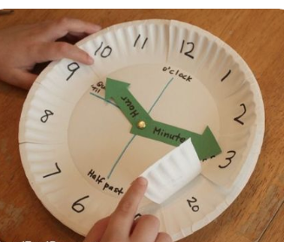

DAISY FOOTPRINTS
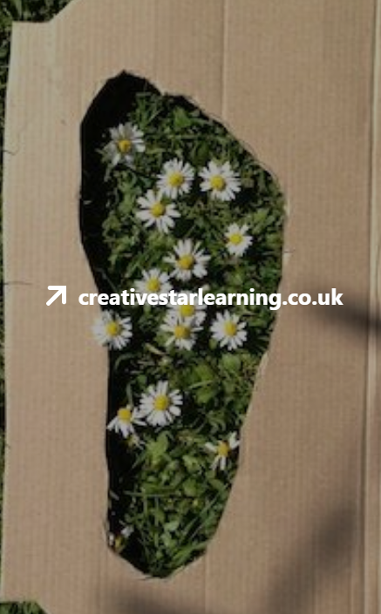
How many daisies can you stand on in one footprint?

FOREST SCHOOL
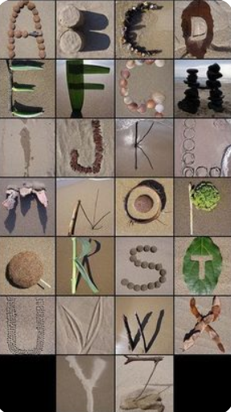.
Can you make all the letters of the alphabet using natural materials?

WOODLAND DRAGONS
Your child may well have played with chalks on paving flags, but giant chalks are also good for drawing on trees. The textured bark is really satisfying to draw on, helping children develop fine motor skills, pencil grip and mark-making, as well as creativity.
Try looking for knots in trees that look like dragons’ eyes and using the chalks to draw on the surrounding area: the bumpy bark makes brilliant dragon skin.
HISTORY
Who was Professor Stephen Hawking?
Discover the story of Stephen Hawking and his life’s work to explain the secrets of the universe! What an inspirational man he was
Use BBC Bitesize

ART & MATHS
Leaf Symmetry
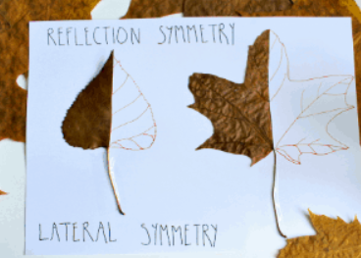
Use your scissors to cut along the central line of a leaf: from stem to tip.
Then stick your half-leaf down in your nature journal or on your sheet of paper.
Can you complete the other half?
Take your time, and look very carefully at the shape of your leaf. See if you can follow the lines and bumps exactly on your half.
You might like to use a pencil, so you can rub out any wobbles!

SUPER SCIENCE
Rain Cloud in a Jar Experiment

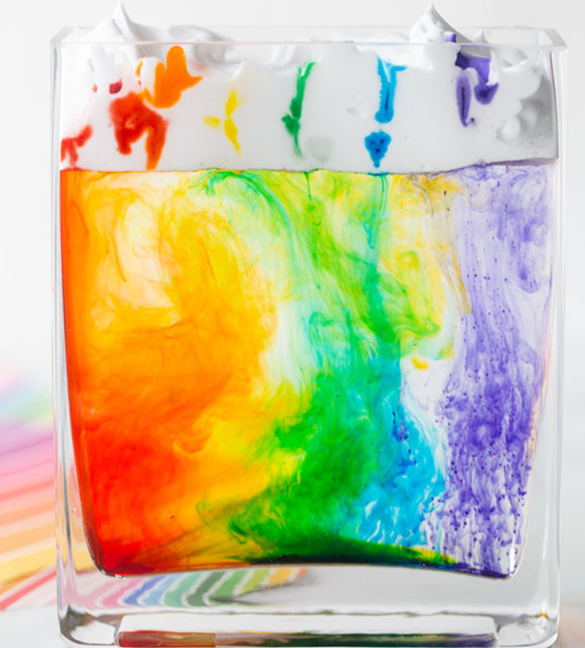
You will need:
  - Clear Vase or Jar
  - Shaving Cream
  - Food Colouring Gel (one in each colour of the rainbow) – we like to use this liquid food colouring gel since it’s concentrated and makes the colours really vibrant
  - Droppers – if you want to do the rainbow of colours, you’ll need 6 droppers to separate out the colours
  - Water
  - Small Bowls for the Food Colouring
Cloud formation happens when water vapour rises into the air. When this vapour hits cold air, it turns into tiny droplets of water. These droplets start to stick together and form clouds. When the clouds get full of water that they can’t hold anymore, the water falls down as rain.
In this experiment, the clouds are the shaving cream and the food coloured water is the rain. As you drop the coloured water into the cloud the weight of the water forces itself through the cloud to “rain” down into the jar.

Add a few drops of food colouring gel for each colour (red, orange, yellow, green, blue, purple) into a small bowl for each colour. Add a little bit of water to dilute it, but not too much to keep the colours vibrant. Add a pipette into each bowl of food colouring.
Fill your vase or mason jar about 3/4 full of water.
Add shaving cream on top.
Now you can start dropping your “raindrops” into the vase or jar. The drops will slowly make their way through the “clouds” into the water. If you find they are not dropping down, you can also push the pipette a little bit more into the shaving cream (but be careful not to push too far or you’ll end up in the water).
Kids can have fun mixing up the colours they add to the jar. Or they can try adding the colours in the order of the rainbow to make a rainbow version!
To make the rainbow version, you will need 6 bowls (one for each colour – red, orange, yellow, green, blue, purple). Then quickly add each colour in the order of the rainbow.
FOREST SCHOOL
Alphabet
Can you make the letters of the alphabet using natural materials?

COTHERSTONE BOOK CORNER
Using the Oxford Owl website you can access these eBooks for FREE
Recommended reads
Key Stage 1-Sport, Then & Now
Key Stage 2-Real Heroes

SCIENCE

How to Grow a Rainbow Science Experiment

Did you know that you can grow your own rainbow?

You will need a scientific process called the capillary action. This action happens when a liquid moves up through a hollow tube or into a spongy, solid material. It happens when three forces work together: cohesion, adhesion and surface tension.

Water molecules like to stick to each other -this is called cohesion. They also like to stick to solids in a process called adhesion.

In this experiment, you are going to use kitchen roll. The fibres in kitchen roll have lots of little holes. Water is absorbed through the kitchen roll because when the first water molecules adheres to it and begin to move upward, it pulls the next water molecule up with it, like a chain.

You will need:
- Kitchen roll
- Felt tip pens
- Two small bowls of water
- Paperclip
- Thread

What to Do:
- Cut the kitchen roll into the shape of a rainbow.
- At each end, use the felt-tip pens to colour a rainbow about 2cm up from the bottom. Remember the order of the colours: red, orange, yellow, green, blue, indigo, violet.
- Attach the paper clip to the top of the rainbow and tie a piece of thread to it. This will allow you to hold your rainbow.
- Add water to the two bowls.
- Hold the rainbow with both end slightly submerged into each bowl of water and watch your rainbow grow.

Take care everyone and as always keep smiling! Look out for Issue 7
Disclaimer: Durham County Council and Cotherstone Primary school are not responsible for the content of these websites. Parents and Carers are advised to check suitability before allowing children any access.

