15/06/20
Hello all children, parents and carers,
We hope you’re all still keeping safe, well and happy!
GARDEN-ing!
Nature Collection Bottles
Recycle a plastic bottle by going on a nature walk and fill it with lots of wonderful, colourful things found outdoors.
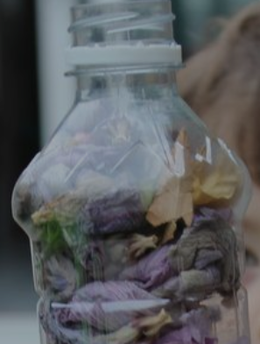

Here are our latest activities which we hope you are enjoying. They continue to be designed as a supportive resource, to use when you feel and if it fits into your day or week. You’re all continuing to be amazing! Well done children and parents of Cotherstone Primary School!
Create your own jigsaw
Draw a picture on a piece of paper. Cut it out into 10/20 pieces and then ask a family member to put it back together again.
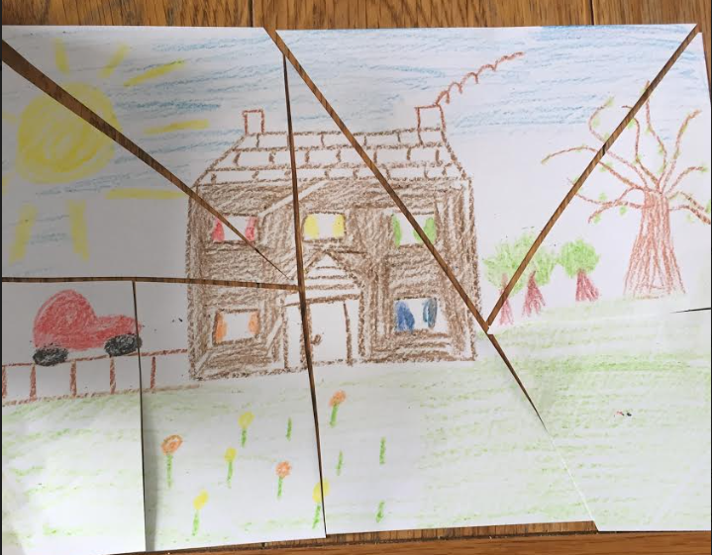

ART & MATHS
Shape Monsters College
Colour/draw some 2D shapes. Cut them out and add detail to them to turn them into fun monsters
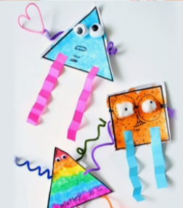

Moist Breath Zone
Video – A health and safety song for New Zealand children going back to school after COVID-19 lockdown. It is a nice catchy song that we are going to learn too in school.
https://www.healthnavigator.org.nz/videos/c/coronavirus-videos/moist-breath-zone/

Poetry Corner
Can you write a poem about ‘Lockdown’?
What have you enjoyed doing best at home?

COTHERSTONE BOOK CORNER
Recommended Reads
Use the fantastic and free ‘Oxford Owl’ website to access these ebooks
Key Stage One- Winnie and Wilbur Stay at Home
Key Stage Two- The Life of Leonardo

Paint a Pebble of Happiness

Choose a small stone/ pebble and paint a picture or colour. Any design that makes you feel happy! Feel free to put them outside our main school entrance and we shall try to display them around there or in our community garden on the front of the school.

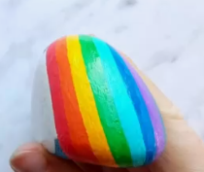
FOREST SCHOOL
Make a Nature Frame
Weave some string around your frame and then go outdoors and find things to put inside it.

HISTORY
.
Who was Queen Victoria?
Discover the story of Queen Victoria who reigned for 63 years and ruled over 400 million people in the British Empire.

Use BBC Bitesize to support.

COOKERY CORNER
No Bake Unicorn Fudge

Ingredients
- 800 g icing sugar
- 10 tbsp condensed milk
- 1 tsp vanilla extract
- Food colouring (I used red, blue and green)
- 100 g softened butter
- Cream the butter, condensed milk and vanilla extract together.
- Add in the icing sugar and give the mix a good whiz with an electric mixer - you could do it by hand but it will take much, much longer.
- When the mixture starts to look a bit like breadcrumbs then you can get your hands in and pull it all together into a ball.
- Split the mix into 3 balls and add a few drops of food colouring to each one. I added red to one ball, blue to another and green to the last one and gave each a good squidge to evenly distribute the colour throughout.
- If you feel the mix is getting too wet then just add a handful more icing sugar. 😉
- The next stage is hard to describe but basically you need to assemble your Unicorn Fudge. I used a small (18cm x 30cm) sized silicon baking tray for my fudge and I basically just split the red ball of fudge into about five smaller balls and dotted them randomly in the baking tray. I did the same with the blue and then used the green to fill in any gaps. Then I squished it all down quite hard using my hands making sure that it was all joined together and would set as one piece rather than break apart where the colours met.
- After that you can squish lots of sprinkles into the top and put it in the freezer for an hour to set (which I do because I'm too impatient to wait for it to set in the fridge overnight).
- You can then cut it to size and pop it in the fridge until you're ready to use it. I don't know how long it stores for as we've never had a batch last longer than five days before it's eaten but I can say it lasts five days.
Recipe taken from: https://www.frugalfamily.co.uk/no-bake-unicorn-fudge/
Take care everyone and as always keep smiling! Look out for Issue 5
Disclaimer: Durham County Council and Cotherstone Primary school are not responsible for the content of these websites. Parents and Carers are advised to check suitability before allowing children any access.

