Costs

Entry – First entry at 9:30am
Basic ticket (just entry, no rides included) - £4 per person
Bronze ticket (entry plus one ride) - £7 per person
Silver ticket (entry plus two rides) - £9 per person
Gold ticket (entry plus three rides) – £10 per person
Platinum ticket (entry plus unlimited rides) - £15 per person

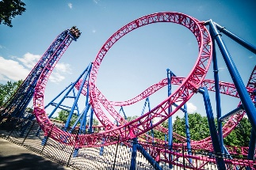
Rides - £2.50 per ride. Last ride at 4:00pm.

Super Thriller Ride – Takes 15 minutes.

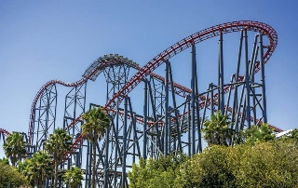
Mega Awesome Ride – Takes 15 minutes.

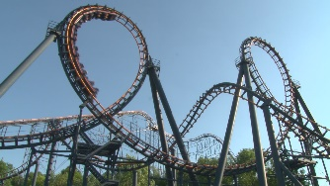
Twister Extreme Ride – Takes 20 minutes.

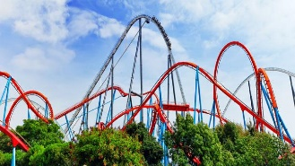
Deluxe Monster Ride – Takes 20 minutes.

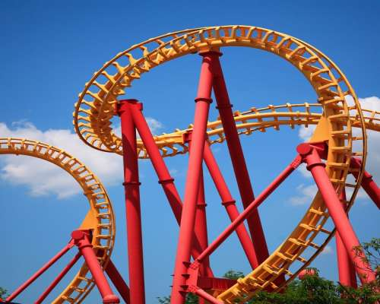
Hoopa Loopa Twirler Ride – Takes 30 minutes.

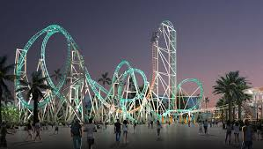
Neon Dream Ride – Takes 30 minutes.

