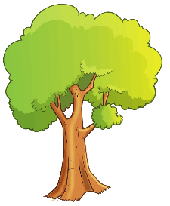
EYFS and KS1 Maths Scavenger Hunt
How many of these can you find?
Square
Rectangle
Triangle
Circle
With a number on
A repeating pattern
Taller than you
Shorter than your little finger
Two different things which are the same length
The same length as your foot
KS2 Maths Scavenger Hunt
How many of these can you find?
Square
Rectangle
Equilateral Triangle
Sphere
Cuboid
The same length as your foot
Shorter than your little finger
With a prime number on
A repeating pattern
With one line of symmetry
With two lines of symmetry
An acute angle
An obtuse angle
A right angle

