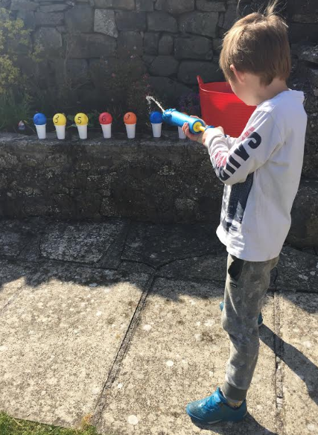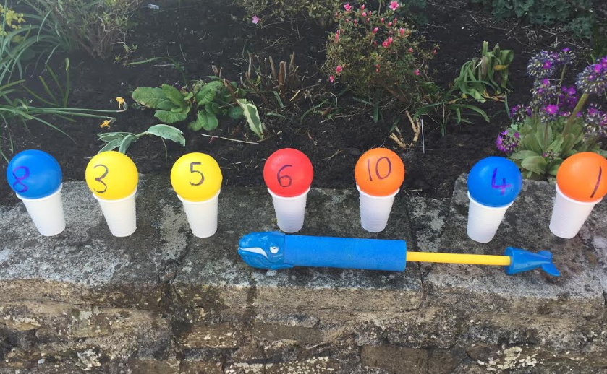

This was a really fun activity that I did today with my children in the garden. All you need is some old plastic balls/ping pong balls or airflow balls that you can write on, some plastic cups and water blasters.
The amount of actitivites you can do are endless and adaptable for any age.
For example:
- Say a number and zap it for number recognition
- Zap two or more numbers togther to add or subtract
- Zap a number that is greater/less than…
- Zap the numbers from smallest to largest
- Zap the odd or even numbers
You can even do this with letters or words!
A little tip is, if it is windy half fill your cups with water first so they don’t blow over!
Have fun!
Miss Lee

