Maths Homework Grid (Y1)

Learn 5 addition facts, play a maths game and choose one other thing to work on each day. The video links are there to help you understand the activities.

Addition facts  Choose 5 addition facts from the grid on the next page to practise each day.  Start by practising the green and blue facts first.  Spend 5 minutes each day practising your number bonds to 10 and to 20. | Maths Games  Choose a maths game to play each day.  Have a go at inventing your own maths game.
One more and one less  Get some raisins, grapes, cereal pieces. Place some on a plate. If the grown up with you says ‘one more’, add one more and say what number you have now. If they say ‘one less’, eat one and count how many you have left.  Ask a grown up to give you some toys. Count how many you have. Can you put out another group of toys so you have one more and then one less?  Build a tower with bricks. Can you build another tower with one more brick? Can you build another with one less brick? | Addition  Make your own tens frames or print some off the internet and use counters, or anything you can find to use instead of counters (raisins, grapes, cereal pieces etc…..). Choose 2 numbers 1-digit numbers to add together , e.g. 7 + 5. On your tens frame set out 7 on one thing, e.g. raisins and then add another 5 of something else e.g. cereal pieces. Have you filled a tens frame? How many are in the next tens frame? What is your answer? Try this adding different numbers. You can also draw them out.
Number bonds to 10  Practise your number bonds to 10 by playing the ‘Total of 10’ card game  Can you think of any new rules for playing this game? | Subtraction  Use your tens frames and counters from the addition activity to practise subtracting. Make the first number using the tens frame and subtract the number of counters/ pieces to work out how many you now have. Try it with different numbers.
Represent different numbers  Make your own tens frames or print some off the internet and use counters, or anything you can find to use instead of counters (raisins, grapes, cereal pieces etc…..) Start by using one tens frame to make numbers up to 10, then use a second tens frame to show numbers up to 20. You can also draw them out.  Use some raisins, grapes, cereal pieces to help you find $\frac{1}{2}$ , $\frac{1}{4}$ and $\frac{1}{3}$ of a set of objects. Use your teddies to help you. If your finding $\frac{1}{2}$ - share them between 2 of your teddies, $\frac{1}{4}$ – share them between 4 of your teddies and $\frac{1}{3}$ – share them between 3 of your teddies. Once you have done this, ask your grown up to draw some bar models (Split a rectangle 2 to work out $\frac{1}{2}$ , 3 to work out $\frac{1}{3}$ and 4 to work out $\frac{1}{4}$  Link to video for finding fractions of amounts using the bar model: | Fractions of shapes  Find things you can cut into halves and quarters, e.g a pizza, a cake, an apple.  Ask your grown up to draw some circles on a page. Can you split them into halves and quarters?  Count in multiples of 2, 5 and 10  Use raisins, grapes, cereal pieces etc… to help you practise counting in multiples of 2, 5 and 10.  Group into 2s to practise counting in 2s, group into 5 to practise counting in 5s and into 10 to practise counting in 10s.  Once you’ve done it with the objects, draw out circles to help you practise counting in 2s, 5s and 10s.
Time to o’clock and half past  Ask your grown up to draw a number line from 1-12 and cut out an arrow (this will be your hour hand). Each number represents an hour on the clock, so if the arrow points to 1 it is showing 1 o’clock. Position your arrow on different numbers and read out the time. Then put your arrow half way between 2 numbers. This represents half past, so if your arrow is half way between 2 and 3, it is half past 3.  Next draw a round clock and do the same with just one hand. Once you are happy telling the time with one hand, you can make a 2nd longer hand. This is your minute hand. Where should it point for o’clock? Where should it point for half past? | Read and write numbers from 1-20 in numbers and in words  Make 1-20 number cards and one to twenty word cards out of paper.  Have a go at matching up the numbers and words. Play the memory game, by turning all your cards over and taking it in turns to pick 2 cards. If the number and word matches, you get to keep both cards. The winner is the person with the most pairs at the end.
2D shapes and 3D shapes  How many 2D and 3D shapes can you name? Go round your house/garden and make a list of all the circles, squares, rectangles and triangle shapes you can see. Can you find any other 2D shapes? Then go round looking for 3D shapes (cubes, cuboids, cylinders and spheres). Can you find any others?  Ask your grown up to cut out some 2D shapes. Can you make different pictures with them? Try drawing out a picture using just 2D shapes. | Mass/weight  Follow a recipe to bake some biscuits or cakes. Can you weigh out all the ingredients yourself?  Find food in your kitchen, such as a tin of beans. Can you find something which is heavier and something which is lighter?
Money  Ask your group up for some money. Can you identify all the coins?  Can you make 10p? Can you find a different way to make 10p, using different coins? Try this for different amounts of money | Length  Find something in your house you could use to measure with. They all need to be the same size e.g. counters, lego bricks, paper clips etc…. Choose different objects, such as a pen or book. Estimate how many counters etc… long it will be and then use them to measure what it actually is. Can you find different things round your house which are longer/shorter.
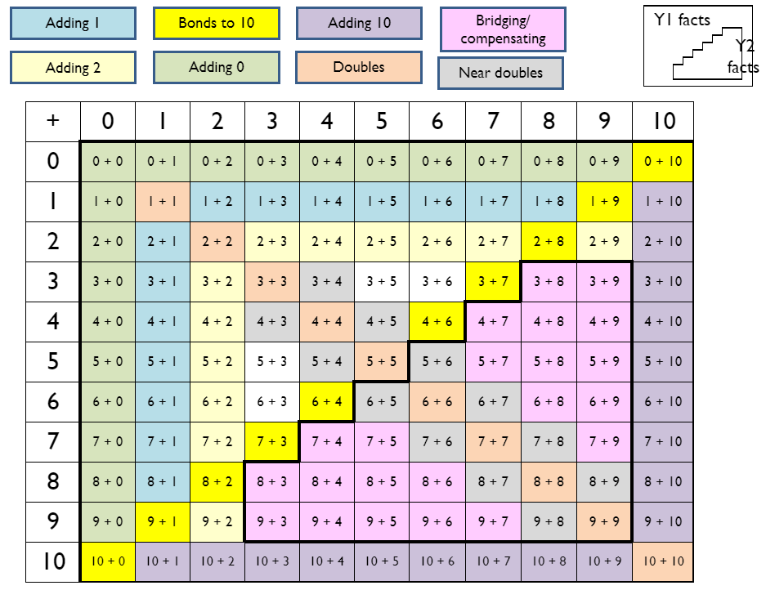
Maths Homework Grid (Y2)

Practise your number facts, play a maths game and choose one other thing to work on each day. The video links are there to help you understand the activities.

Number facts  Choose 5 addition facts from the grid on the next page to practise each day.  Spend 10 minutes each day practising your number bonds, doubling & halving and times tables.  Link to a website for practising:  https://www.topmarks.co.uk/maths-games/hit-the-button | Place value  Make your own tens and ones using straws, tooth pics, pencils (or anything else you can think of which you can make into bundles of ten). Have a go at using them to make different 2-digit numbers. Use plates to make your own part-whole models.  Once you are confident, have a go at drawing out your tens and ones as pictures.  (Link to video in next box)
Maths Games  Choose a maths game to play each day.  Have a go at inventing your own maths game.  Link to a blog on maths games:  https://matr.org/blog/fun-maths-games-activities-for-kids/ | Place value (continued)  Link to place value video:  https://www.youtube.com/watch?v=vBIZal-8Kr4&list=PLWIJ2KbiNEyplZvdo0-OU48R3KSq3ywhV&index
Number bonds to 10  Practise your number bonds to 10 by playing the Total of 10 and the ‘Make 10’ pyramid card game.  Link to the ‘Total of 10’ card game:  https://www.youtube.com/watch?v=SD028NO-ZGc&list=PLWIJ2KbiNEyoBDc5yLJ4PaiaY3o5E5xCB&index=5&t  Link to the ‘Make 10 Pyramid’ card game:  https://www.youtube.com/watch?v=3IFFRWkMWGk&list=PLWIJ2KbiNEyoBDc5yLJ4PaiaY3o5E5xCB&index  Can you make up your own game to practise number bonds to 10? | 10 more and 10 less  Make your own tens and ones using straws, tooth pics, pencils (or anything else you can think of which you can make into bundles of ten).  Make your own tens and ones baseboard and practise adding and subtracting 10 from your number.  Link to video on adding 10:  https://www.youtube.com/watch?v=gqUtj9rkYCU&list=UUob4tkfOSXy6yav9Y54SKIQ&index  Link to video on subtracting 10:  https://www.youtube.com/watch?v=ZWhOUv5mC9s&list=UUob4tkfOSXy6yav9Y54SKIQ&index
Place value  Play the ‘Guess my Number’ place value game. Make 2 sets of 2-digit  Link to ‘Guess my Number’ video:  https://www.youtube.com/watch?v=wzvQ5R-A0Bk&list=PLWIJ2KbiNEyoBDc5yLJ4PaiaY3o5E5xCB&index | Addition  Practise adding numbers together by playing games with dice. Have a go at playing ‘Pig’ and ‘Skunk’ and then try and think of your own game  Link to dice game ‘Pig’:  https://www.youtube.com/watch?v=foj6ujoT_HU&list=PLWIJ2KbiNEyoBDc5yLJ4PaiaY3o5E5xCB&index  Link to dice game ‘Skunk’:  https://www.youtube.com/watch?v=-SWReEQOVr4&list=PLWIJ2KbiNEyoBDc5yLJ4PaiaY3o5E5xCB&index
Column addition of 2-digit numbers  Make your own tens and ones using straws, tooth pics, pencils (or anything else you can think of which you can make into bundles of ten).  Use them to have a go at adding 2 2-digit numbers and to understand what happens when your 2 digits add to 10 or more.  Link to column addition of 2-digit numbers video:  https://www.youtube.com/watch?v=hHM25Nx4vhg&list=PLWIJ2KbiNEyq1iZ36fRe-xTJ4NNZsmYz9&index | Fractions of amounts  Find some things you can use to share out, to practise finding fractions of amounts. E.g. raisins, grapes, sweets etc….  Share them out between 2 teddies to find $\frac{1}{2}$ and then between 4 teddies to find $\frac{1}{4}$ of them. Draw a bar model split into 2 to find halves and into 4 to find quarters.  Link to video on fractions of amounts:  https://www.youtube.com/watch?v=PgrF1TYXP6Y&t
Column subtraction of 2-digit number  Make your own tens and ones using straws, tooth pics, pencils (or anything else you can think of which you can make into bundles of ten).  Use them to have a go at subtracting 2 2-digit numbers and to understand what happens when your 2 digits add to 10 or more.  Link to column subtraction of 2-digit numbers video:  https://www.youtube.com/watch?v=pADFYrGdyYE&list=PLWIJ2KbiNEyq1iZ36fRe-xTJ4NNZsmYz9&index | Time (o’clock, half past, quarter past and quarter to)  Why don’t you make your own clock and have a go at telling the time to o’clock and half past using just the hour hand. Once you are confident with that, have a go at telling the time to quarter past and quarter to.  Once you have tried it using just the hour hand, bring in the minute hand too.  Link to video on time (o’clock and half past):  https://www.youtube.com/watch?v=V32tRiEQ2AA&t  Link to video on quarter past and quarter to:  https://www.youtube.com/watch?v=86RbCwhdJSs&t
Division as grouping and sharing  Find things around the house you can use to practise division as sharing and division of grouping. You could use raisins, grapes, lego bricks etc…  Link to video on division as grouping and sharing:  https://www.youtube.com/watch?v=bdglIPNNhuI | 2D and 3D Shapes  How many 2D and 3D shapes can you name? Go round your house/garden and make a list of all the circles, squares, rectangles and triangle shapes you can see. Can you find any other 2D shapes? Then go round looking for 3D shapes (cubes, cuboids, cylinders and spheres). Can you find any others?
Equivalent fractions  Find different things you can use to prove that a half is equal to 2 quarters. Cut a pizza/cake, share raisins, grapes, lego out into halves and quarters.  Link to video on fractions equal to a half:  https://www.youtube.com/watch?v=ieT9k537jP4&list=PLWIJ2KbiNEypS0zxt54Wez5X4gnQ-xxvu&index | Money  Ask your parents for some money. Can you identify all the coins?  Can you make 50p? Can you find a different way to make 50p, using different coins? Try this for different amounts.

